1. Create an employee table with following fields

Empno : Number(10)( primary key)

Ans: CREATE TABLE EMP(EMPNO NUMBER(4) PRIMARY KEY,ENAME VARCHAR(12),SALARY NUMBER(10),COMMISSION NUMBER(7) ,DEPTNO NUMBER(20));

INSERT VALUES: INSERT INTO EMP VALUES(&EMPNO,'&EMPNAME',&SALARY,&COMMISSION,&DEPTNO);

ANS:

Enter value for empno: 1

Enter value for empname: GAYATHRI

Enter value for salary: 20000

Enter value for commission: 60

Enter value for deptno: 3

old 1: INSERT INTO EMP VALUES(&EMPNO,'&EMPNAME',&SALARY,&COMMISSION,&DEPTNO)

new 1: INSERT INTO EMP VALUES(1,'GAYATHRI',20000,60,3)

1 row created.

DISPLAY ALL RECORDS

SELECT * FROM EMP;

EMPNO ENAME SALARY COMMISSION DEPTNO

---------- ------------ ---------- ---------- ----------

2 GAYATHRI 32000 600 1

7 KUTTUZ 802 6 4

6 FIDHA 6028 6 9

1 GAYATHRI 20000 60 3

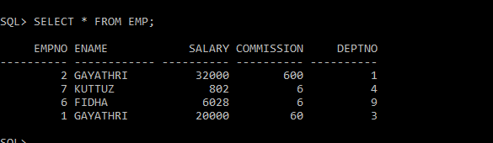

*ALTER TABLE

ALTER TABLE EMP ADD(JOB VARCHAR(20));

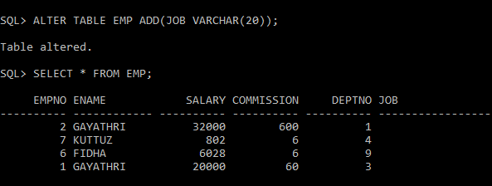

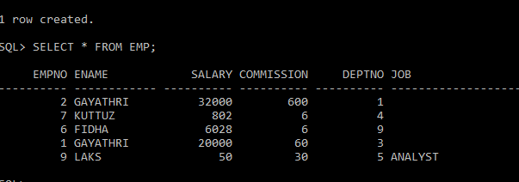

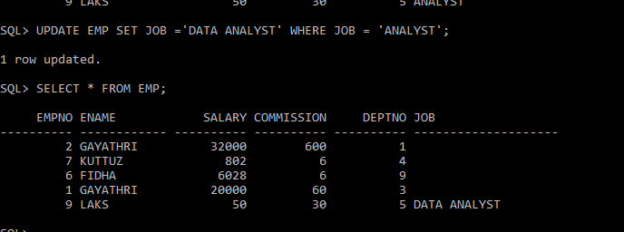

ALTER TABLE:

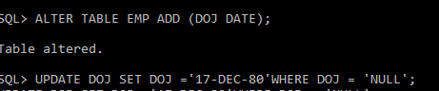

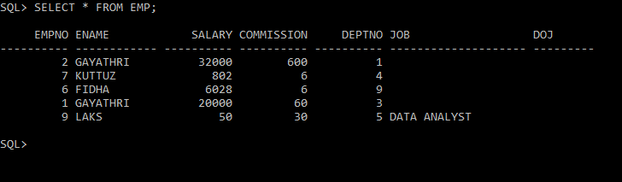

UPDATE DATE:

SQL> UPDATE EMP SET DOJ ='17-DEC-80'WHERE EMPNO = 1;

SQL> SELECT * FROM EMP;

EMPNO ENAME SALARY COMMISSION DEPTNO JOB DOJ

---------- ------------ ---------- ---------- ---------- -------------------- ---------

2 GAYATHRI 32000 600 1

7 KUTTUZ 802 6 4

6 FIDHA 6028 6 9

1 GAYATHRI 20000 60 3 17-DEC-80

9 LAKS 50 30 5 DATA ANALYST

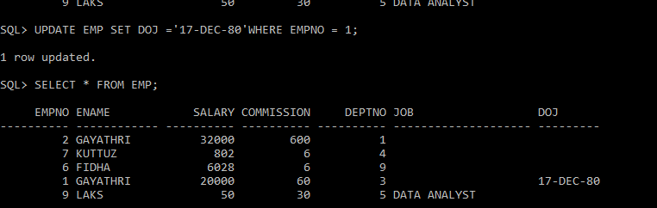

*DISPLAY ALL DISTINCT JOB TYPE:

SQL> SELECT DISTINCT JOB FROM EMP;

JOB

--------------------

DATA ANALYST

**\*DISPLAY EMP NO,EMP NAME,JOB FROM TABLE**

SQL> SELECT EMPNO,ENAME,JOB FROM EMP;

EMPNO ENAME JOB

---------- ------------ --------------------

2 GAYATHRI CLERK

7 KUTTUZ ACTOR

6 FIDHA HR

1 GAYATHRI QA

9 LAKS DATA ANALYST

*

SQL> SELECT EMPNO,ENAME,JOB FROM EMP;

EMPNO ENAME JOB

---------- ------------ --------------------

2 GAYATHRI

7 KUTTUZ

6 FIDHA

1 GAYATHRI

9 LAKS DATA ANALYST

**\* DISPLAY ENAME FROM EMP WHERE EMPID=1**

SQL> SELECT ENAME FROM EMP WHERE EMPNO=1;

ENAME

------------

GAYATHRI

\***FIND TOTAL SALARY OF ALL EMPLOYEES**

**SQL> SELECT SUM(SALARY)FROM EMP;**

**SUM(SALARY)**

**-----------**

**58880**

**\*LIST NAME AND TOTAL SALARY+COMMISSION**

**>SQL> SELECT ENAME,SUM(SALARY+COMMISSION)FROM EMP GROUP BY ENAME;**

**ENAME SUM(SALARY+COMMISSION)**

**------------ ----------------------**

**FIDHA 6034**

**KUTTUZ 808**

**LAKS 80**

**GAYATHRI 52660**

**SQL>**

**\*FIND TOTAL SALARY GROUP BY JOB**

**SQL> SELECT JOB,SUM(SALARY+COMMISSION)FROM EMP GROUP BY JOB;**

**JOB SUM(SALARY+COMMISSION)**

**-------------------- ----------------------**

**59502**

**DATA ANALYST 80**

**SQL>**